Norfolk County Council

Road Traffic Regulation Act 1984 – Sections 14(1) and 15(3)

Notice (STRO1106)

Notice is given that the Secretary of State for Transport has approved the continuing in force for the period set out below of an Order made by the Norfolk County Council under the Road Traffic Regulation Act 1984, prohibiting the use by vehicles of C194 Mill Lane from its junction with A140 Ipswich Road for 1275 metres eastwards in the Parish of Shotesham because of the likelihood of danger to the public.

Date of Original Order: 28th June 2024

Previous restriction period: 23rd May 2024 to 1st August 2026

Period of extension: 1st August 2026 to 1st February 2027

Alternative route is via: Norwich Road, Cargate Lane, A140 Ipswich Road (Shotesham, Newton Flotman).

Persons who contravene the Order will be liable, on conviction, to a fine.

Full details on the closure are available at https://one.network. Any enquiries that cannot be answered on the one.network website should be directed to the South Area Streetworks (Infrastructure Department) contactable by telephone at 0344 800 8020 or email at streetworks@norfolk.gov.uk

Dated this 24th day of July 2026

Katrina Hulatt
Director of Legal Services (nplaw)
County Hall
Martineau Lane
Norwich
NR1 2DH

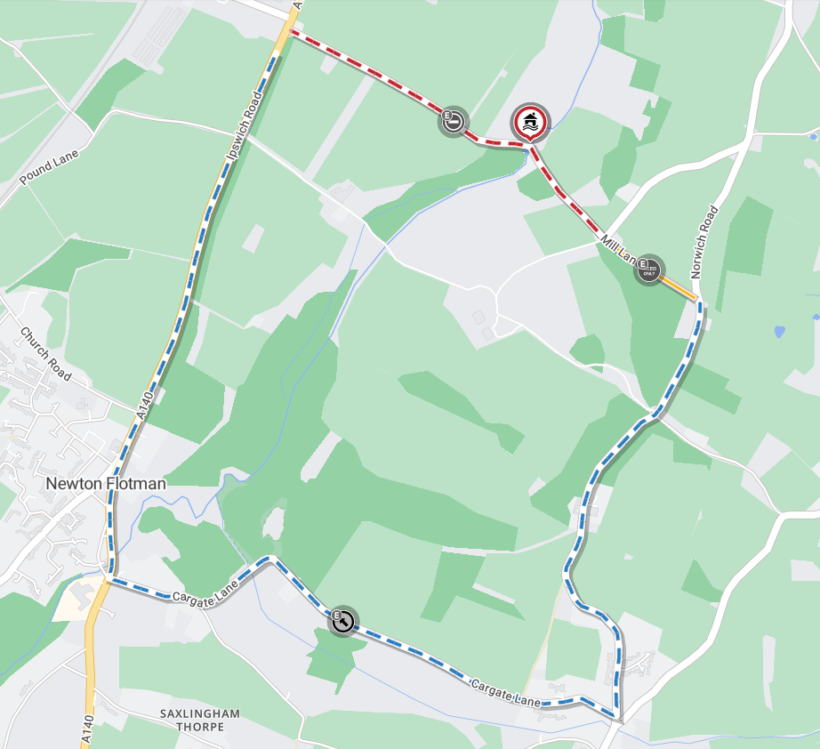
Map data © maptiler © openstreetmap contributors

