What goes in your recycling bin?
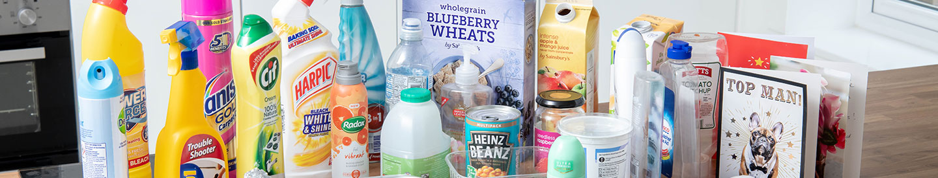
In Norfolk we can recycle more items than ever. If you are not sure whether an item can be recycled, you can find out in this section.
You can also find out where there are recycling centres that can recycle items we’re unable to take, and information about what happens to your recycling after we collect it.
If you occasionally have too much recycling for your bin, you can leave any extra items in a clear sack or recyclable container at the side of your bin. You can use a cardboard box, but it should not contain breakable objects for safety reasons. The box must be a size to fit into the wheelie bin.
Please do not leave cardboard out if the weather is bad. We cannot collect wet cardboard as it will not be recycled.
Please be aware if the crew are near capacity they will have to prioritise the bins over side waste and may not be able to take it.
Download our Broadland Bin App to find out more about recycling, as well as keeping up to date with your bin collections.
Download our South Norfolk Bin App to find out more about recycling, as well as keeping up to date with your bin collections.

What can I put in my recycling bin?
The following items can be recycled in your recycling bin.
All recycling must be:
- clean – please rinse containers and do not put in any food leftovers
- loose – please do not put anything in plastic bags or black bin liners
- dry – please ensure the bin lid remains shut

Paper and cardboard
- newspapers/magazines
- leaflets
- packaging card and cardboard
- wrapping paper (clean and without adhesive tape, ribbons and glitter)
- greeting cards
- envelopes (including those with windows)
- catalogues/telephone books
- shredded paper
- junk mail (without the plastic wrapping)

Metal tins, cans and foil
- all steel and aluminium cans and tins
- clean foil trays and containers
- empty aerosol cans
- aluminium foil

Plastic containers
- milk and drink bottles (lids on)
- bathroom bottles (lids on including trigger and pump spray bottles)
- food and ready meal trays (including black plastic trays)
- fruit and vegetables punnets
- yoghurt, cream and soup pots
- ice cream and margarine tubs

Food and drink cartons
- milk cartons
- juice cartons

Glass
- glass bottles - lids on
- glass jars - lids on

What can't go in your recycling bin
The following can't be recycled:
- plastic bags, cling film and junk mail bags -many supermarkets have collection points for these materials
- plastic or foil based wrapping paper with adhesive tape, ribbon and glitter
- crisp and sweet packets
- food waste
- pouches (baby and pet food)
- toothpaste tubes
- toys (hard plastic)
- polystyrene packaging
- unopened recyclable items still containing food or liquids
- flower and plant pots
- DIY waste
- nappies
- window or mirror glass
- drinking glasses
- light bulbs
- plastic engine oil bottles
- textiles - please use the textile banks located at mini recycling centres or in Broadland the kerbside textile service
- wallpaper
- sharps such as needles
- garden waste
- animal waste
For a full list please visit the Norfolk Recycles website.
We will not collect your bin if it contains any items (including plastic bags) that can’t be recycled.

