NORFOLK COUNTY COUNCIL proposes to make a Temporary Traffic Order affecting the U78123 Wash Lane from its junction with U78123 Chequers Lane for 140m northwards in the PARISH OF SHOTESHAM because of BT pole renewal works.

The road will be temporarily closed (except for access) between 09:30 and 15:30 on 7th January 2022 for the duration of the works expected to be about 6 hours within the period.

Alternative route is via: Wash Lane, Saxlingham Road, Shotesham Lane, The Street, Church Hill, The Green, Chequers Lane (Saxlingham Nethergate, Shotesham).

(If necessary the restriction could run for a maximum period of 18 months from the date of the Order).

Penalty: £1000 maximum fine on conviction and/or endorsement for contravention.

In the event of the start date being delayed the new start date will be displayed on site in advance.

The person dealing with enquiries at Norfolk County Council is Harvey Woodyatt (Community and Environmental Services) Telephone 0344 800 8020.

Dated this 17th day of December 2021

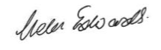

Helen Edwards

Chief Legal Officer

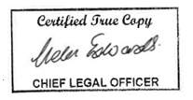

County Hall

Martineau Lane

Norwich

NR1 2DH

Map and plan of road closure and alternative diversion route